**Assignment#1**

**Name: Kulsoom Khurshid**

**Reg #: SP20-BCS-044**

**Course: Database Management**

**Instructor: Mr. Qasim Malik**

**You need to figure out the query in SQL that must produce the expected result. You should test your SQL queries on Oracle Server before submission.**

**Problem-1: Drama-Rating Database**

1. Find the names of all reviewers who have contributed three or more ratings.

**SELECT reviewername FROM (rating natural join reviewer)**

**GROUP BY reviewername**

**HAVING COUNT(stars) >= 3;**

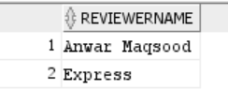

1. For each drama that has at least one rating, find the highest number of stars that drama received. Return the drama title and number of stars. Sort by drama title.

**SELECT title, MAX(stars) FROM (drama natural join rating)**

**GROUP BY title**

**ORDER BY title;**

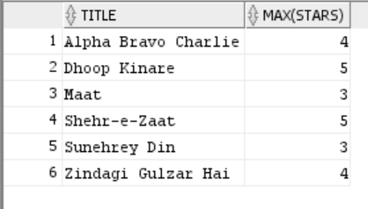

1. List drama titles and average ratings, from highest-rated to lowest-rated. If two or more dramas have the same average rating, list them in alphabetical order.

**SELECT title, AVG(stars) FROM (drama natural join rating)**

**GROUP BY title**

**ORDER BY AVG(stars) DESC, title;**

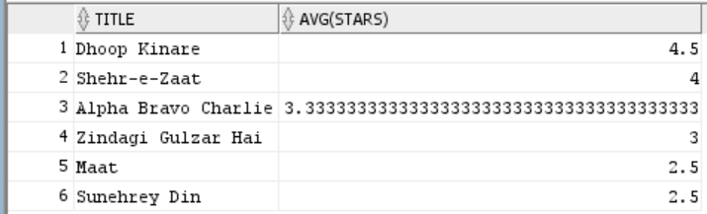

**QUESTION 2)**

**Even though the database contains six relations, however, in order to answer the following set of queries, you only need to use the first four relations.**

1. Find the names of all females who eat at least one pizza served by Rahat.

(Note: The pizza need not be eaten at Rahat)

**SELECT name FROM (eats natural join serves natural join person)**

**WHERE (restaurant = 'Rahat' and gender = 'female');**

